**Test Description:**

Use 10lbs (~1.5 gallons) of liquid nitrogen (LN2) to run a series of individual pump component cooling tests to identify the geometric contraction under cryogenic conditions.

* Initial Room Temperature = 22°C
* Liquid Cryogen Temperature = -196°C
* Component Submersion Time = 120 seconds

These tests will attempt to simulate operating conditions for the pump components to finalize the cryo pump design geometry. Results will be extrapolating to future use with liquid oxygen which boils at -182.19°C

**Goals:**

* Identify contraction metrics under cryogenic conditions
  + Bore size reduction
  + Impeller shaft diameter reduction
  + Entry and Exit Fitting seal
  + Case bolt tension

**Personal protective equipment (PPE)**

* Safety Glasses
* Leather Gloves for handling LN2
* Long Sleeves
* Various pliers for part handling and submersion
  + Needle Nose
  + Vise Grips
* Steel wire for component wrapping
* Plywood board Safety Zone for component warm up

**Procedure:**

*Preliminary Measurements*

1. Fill out all component measurement sheets for room temp \**at end of this document*
   1. *Impeller*
   2. *Shaft Collar*
   3. *Case 1*
   4. *Seal Retaining Ring*
   5. *Case 2*
   6. *Bearing Plate*
2. Wrap individual components with steel wire for safe submersion

*Liquid Cryogen*

1. Acquire 10lbs of LN2 from the SRTC second floor stock room.
   1. Faculty Advisor = Mark Weislogel
   2. Grant Index Number = 244812
   3. Use PSAS dewar if top can be removed,
   4. Acquire open top dewar from SRTC if needed
2. Complete SRTC safety protocol * required only for members acquiring LN2
3. Safely transport LN2 to area outside MME Machine Shop for testing

*Test Trials*

1. *Using PPE Open LN2 dewar to expose boiling liquid cryogen
2. Submerge component into LN2 for a 120 Seconds

Order of Component Submersion

* 1. Impeller
  2. Shaft Coupler
  3. Case 1
  4. Seal Retaining Ring
  5. Case 2
  6. Bearing Plate

1. Carefully measure critical dimensions for submerged component
2. Place cooled component in safe zone to keep from accidental contact
3. Repeat steps 7 - 9 until all components have been submerged and measured
4. *Using PPE Close LN2 dewar lid

*Clean Up*

1. Safely dispose of remaining LN2
2. Transport cooled components on safety board for long term warm up

**Test Day Notes**

**Measurement Sheet**

Impeller

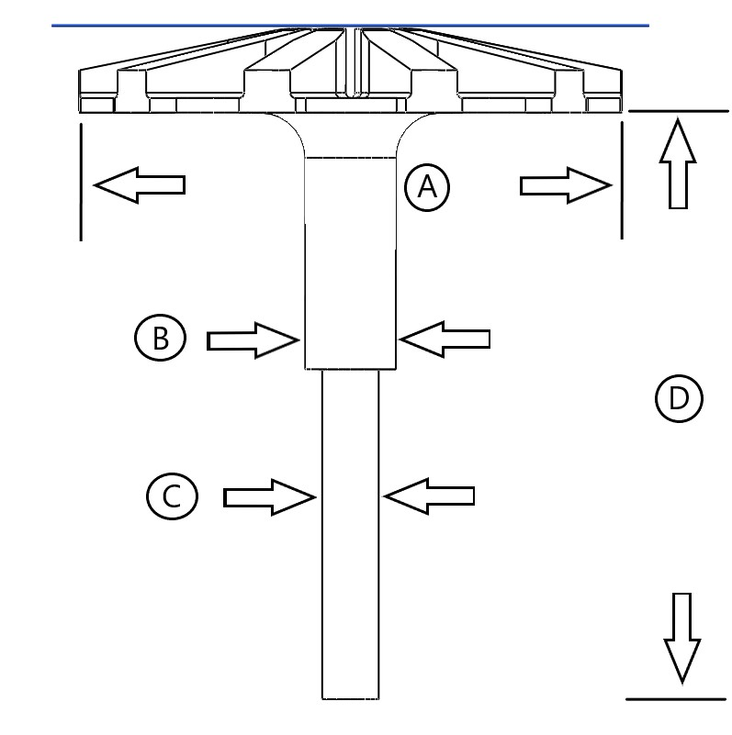

|  |  |  |  |
| --- | --- | --- | --- |
| Component Measured | Room Temp | Cooled | Unit |
| **B**: Impeller Shaft (thick) | 0.5001 | 0.4984 | [in] |
| **D**: Impeller Shaft Length | 3.247 | 3.240 | [in] |

**Measurement Sheet**

Shaft Collar

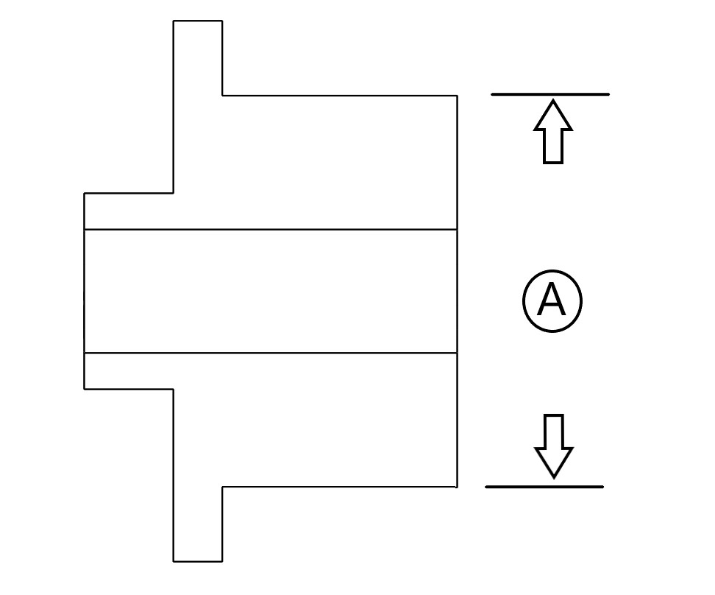

|  |  |  |  |  |
| --- | --- | --- | --- | --- |
| Component Measured | Room Temp | Cooled | Delta | Unit |
| **A:** Bearing Fit Diameter | 0.995 | 0.99197 | 0.00303 | [in] |

**Measurement Sheet**

Case 1

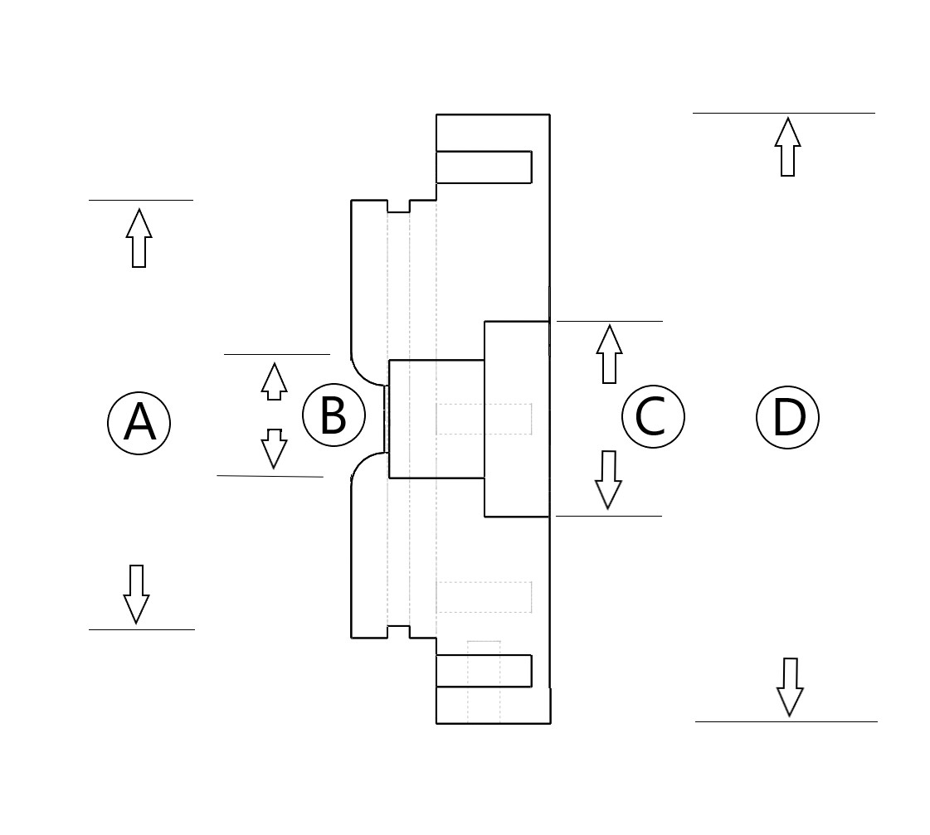

|  |  |  |  |  |
| --- | --- | --- | --- | --- |
| Component Measured | Room Temp | Cooled | Delta | Unit |
| **A:** Impeller Base Extrude Outer Diameter | 3.45013 | 3.440 | 0.01013 | [in] |
| **B**: Impeller Entrance Diameter | 0.9308 | 0.9287 | 0.0021 | [in] |

**Measurement Sheet**

Seal Retaining Ring

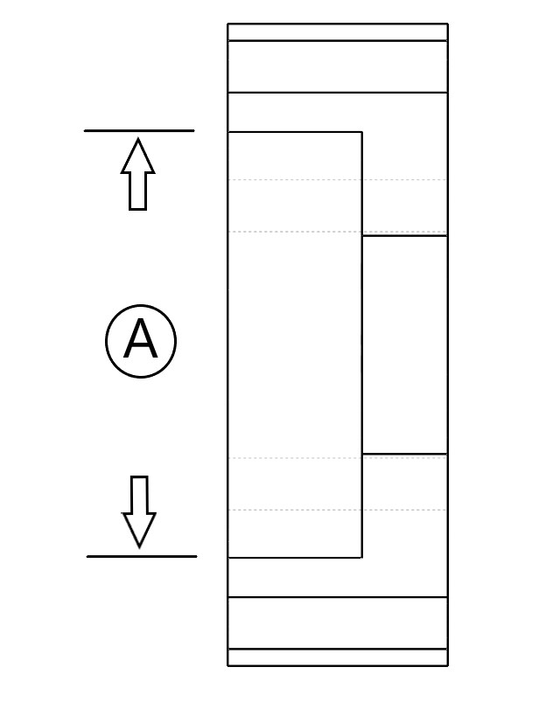

|  |  |  |  |  |
| --- | --- | --- | --- | --- |
| Component Measured | Room Temp | Cooled | Delta | Unit |
| **A:** Seal Insert Diameter | 0.9943 | 0.99187 | 0.00243 | [in] |

**Measurement Sheet**

Case 2

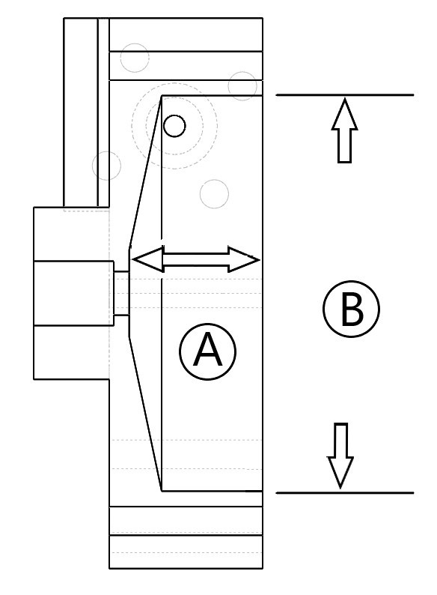

|  |  |  |  |  |
| --- | --- | --- | --- | --- |
| Component Measured | Room Temp | Cooled | Delta | Unit |
| **A:** Impeller Case Depth | 1.167 | 1.159 | 0.008 | [in] |
| **B**: Impeller Base Insertion Diameter | 3.4532 | 3.4408 | 0.0124 | [in] |

**Measurement Sheet**

Bearing Plate



|  |  |  |  |  |
| --- | --- | --- | --- | --- |
| Component Measured | Room Temp | Cooled | Delta | Unit |
| **A:** Bearing Insert Diameter | 1.9693 | 1.9632 | 0.0061 | [in] |